Modeling cost-optimal gas network infrastructure decommissioning: The case of Austria

Sebastian Zwickl-Bernhard[1],2, Hans Auer[2][3]

# Motivation and core objective

In order to limit the increase of the global average temperature to 1.5°C, McGlade and Ekins estimate that about half of natural gas reserve potentials have to remain underground [1]. Accordingly, it is undisputed that the sustainable energy system transformation confronts natural gas network infrastructure with issues related to its role in a decarbonized society [2]. One particularly crucial question concerns the degree of refurbishment investment into the existing gas network in the light of an expected overall decrease in gas consumption and greater, but quantitatively limited, penetration of “green” gas.

The core objective of this work is to investigate the cost-optimal gas network infrastructure in Austria on the path to the climate target year 2050. In particular, the network decommissioning and refurbishment investment decision (e.g., where green gas is used due to missing sustainable alternatives) plays an important role in this analysis. That is closely associated with the avoidance of stranded assets appearing on utility companies’ ledgers. We develop a high spatially (at the district/NUTS3 level with the intention to extend the resolution to the municipality/LAU level in the future) and temporally (i.e., hourly) gas system modeling framework which also depicts the gas network. Thus, the analysis includes not only the long-distance pipeline network but also local low-pressure networks. Latter networks are particularly relevant in the context of upcoming decommissioning decisions (see exemplarily in [3]). The hourly resolution of the modeling framework appropriately models the large-scale gas storages in the networks that mainly serve as seasonal storage.

# Materials and methods

The core of the gas modeling framework is an optimization model which determines the cost-optimal development of the existing gas network infrastructure. Thereby, the objective function can be written as follows:

|  |  |
| --- | --- |
| $$\min_{x}{capex+opex-rev}$$ | (1) |

where $capex$ are the capital costs (i.e., weighted average cost of capital (wacc) times asset’s book value), $opex$ the operational costs (mainly fixed cost), and $rev$ are the revenues associated with the demand coverage and transmission of natural gas at a specific gas network level. Exemplarily, the capital costs of a specific asset $l$ in year $y$ $({capex}_{l,y})$ are calculated as below:

|  |  |
| --- | --- |
| $${capex}_{l,y}=wacc∙\left(Π_{l,y}^{init}+f_{y}^{inv}∙c^{inv}∙Υ_{l,y}^{inv}\right)$$ | (2) |

# where $Π_{l,y}^{init}$ is the book value of the initial (existing) asset, $f_{y}^{inv}$ the depreciation factor of the refurbishment investment, $c^{inv}$ the specific refurbishment investment costs, and $Υ_{l,y}^{inv}$ the asset’s refurbished installed capacity. Equation (3) shows the gas balance constraint at the nodal level

|  |  |
| --- | --- |
| $$q_{n,y,t}^{src}-q_{n,s,y,t}^{dem}-q_{n,s,y,t}^{exp}+q_{n,s,y,t}^{imp}=0$$ | (3) |

where $q_{n,y,t}^{src}$ is the source of gas at node $n$ at time step $t$ per $y$. In addition, $q_{n,s,y,t}^{dem}$ is the amount of gas demand covered at a specific network level $s$ per $n, y$ and $t$. The decision variables $q_{n,s,y,t}^{exp}$ and $q_{n,s,y,t}^{imp}$ are the amount of gas exported and imported respectively.

In terms of materials and data, we particularly build upon the existing open-source tool *esy-osmfilter* [4], which provides relevant data of the existing gas network at high spatial resolution. Besides, the open-data platform *energiemosaik (*[*https://www.energiemosaik.at/intro*](https://www.energiemosaik.at/intro)*)* provides relevant data for this analysis in the context of high-spatial resolved gas demand.

# Preliminary results and conclusions

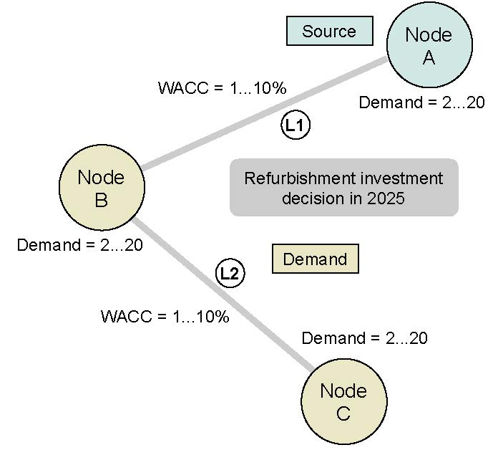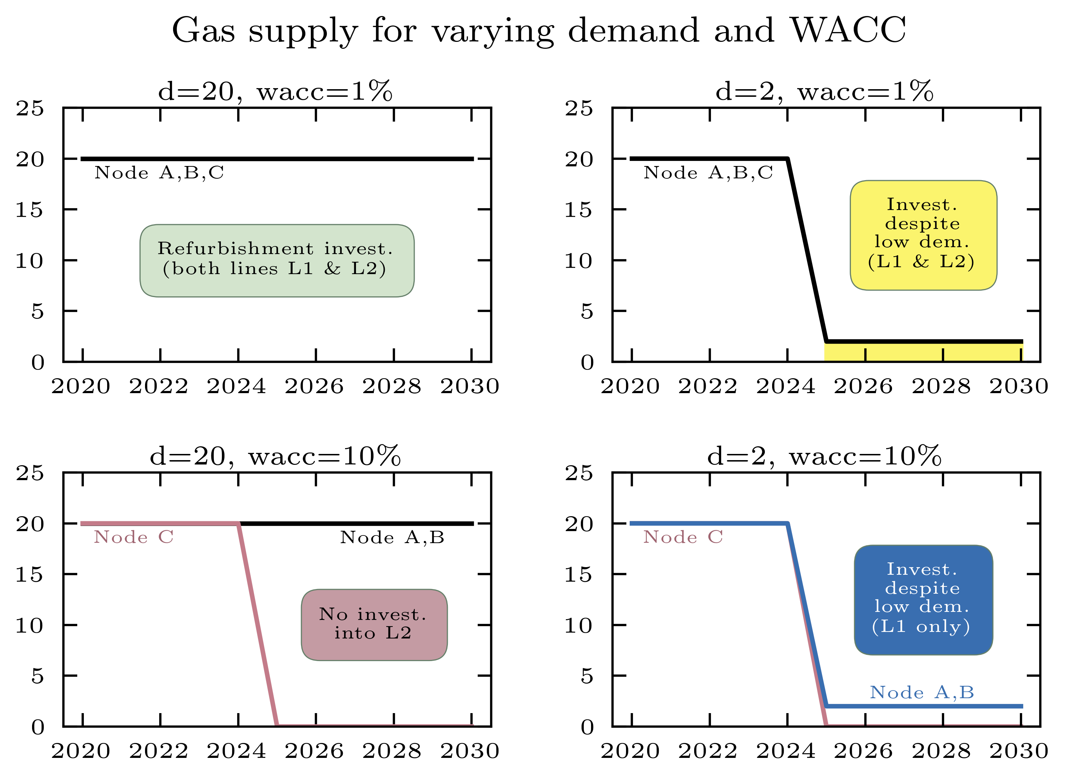We illustrate the functionality and present preliminary results of the model using a simplified network (see in Figure 1). The network consists of three nodes (A, B, and C) and two lines (L1 and L2). The planning horizon is between 2020 and 2030, whereby both lines require a refurbishment investment in 2025 in order to provide the gas demand. Node A is the source node in this network.

Figure 1 Simple gas network   
(three nodes and two lines)

*Figure 2 Gas supply at the different nodes for varying demand and wacc parameter assumptions*

Figure 2 shows the nodal gas supply for varying gas demand and wacc parameter assumptions. Most importantly, it can be seen that the decision to invest in refurbishment depends on both parameters. In particular, a high demand and low wacc as well as low demand and low wacc result in a refurbishment investment decision for both lines L1 and L2 (see top left and right subfigure). In contrast, a high wacc assumption (10%) leads to no investment decision for refurbishment at line L2 independently from the demand development. Hence, the existing high (and low) gas demand at Node C is not covered (see bottom left and right subfigure) and L2 is decommissioned. The results indicate that both the future gas demand and wacc are key determining parameters in the context of refurbishment investment and decommissioning decisions. At the conference, we will present much more comprehensive results regarding a larger supply area in Austria. Based on this, we will show which connection lines remain in operation or are decommissioned in the next years.

# References

[1] McGlade, C., & Ekins, P. (2015). The geographical distribution of fossil fuels unused when limiting global warming to 2 C. Nature, 517(7533), 187-190, doi: <https://doi.org/10.1038/nature14016>.

[2] Giehl, J., Sudhaus, T., Kurre, A., Mikulicz-Radecki, F. V., Hollnagel, J., Wacker, M., ... & Müller-Kichenbauer, J. (2021). Modelling the impact of the energy transition on gas distribution networks in Germany. *Energy Strategy Reviews*, *38*, 100751, doi: <https://doi.org/10.1016/j.esr.2021.100751>.

[3] Zwickl-Bernard, S. & Auer, H. Demystifying natural gas distribution grid decommissioning: An open-source approach to local deep decarbonization of urban neighborhoods. *Energy*, 238, 121805. (2022), doi: <https://doi.org/10.1016/j.energy.2021.121805>.

[4] Pluta, A., & Lünsdorf, O. (2020). esy-osmfilter–A Python Library to Efficiently Extract OpenStreetMap Data. Journal of Open Research Software, 8(1), doi: <http://doi.org/10.5334/jors.317>.

1. Nachwuchsautor; geb. 4.11.1994, [zwickl@eeg.tuwien.ac.at](mailto:zwickl@eeg.tuwien.ac.at)
2. Institut für Energiesysteme und Elektrische Antriebe / Technische Universität Wien (TU-Wien), Energy Economics Group (EEG)
3.